APPENDIX 1: Variables to be extracted from published case reports, series and cohort studies for literature review
Variable | Type of Data
Year of publication | Date
Age of patient at presentation | Integer
Sex | Binary (M/F)
Country of birth (if not specifically mentioned will code the country of the corresponding author) | Free text
Country of corresponding author | Free text
HIV history and other risk factors
Age of HIV diagnosis | Integer
Age rash noted | Integer
Age of ART start | Integer
Likely route of transmission | Categorical  (Likely perinatal / likely transfusion related / likely sexually acquired / unknown)
CD4 count at diagnosis of EV (cells/mm3) | Integer
Viral load at diagnosis of EV (copies/ml) | Integer
CD4 nadir | Integer
Recorded Advanced HIV Disease (CD4 <200 cells./mm3 Or other indicator) | Binary (Yes/No)
Late diagnosis of HIV (CD4 <350 cells/mm3) | Binary (Yes/No)
HIV Treatment at time of presentation | Free text
Response to ART | Categorical (Complete/Partial/ No)
Other risk factors
Lymphoma | Binary (Yes/No)
Lupus | Binary (Yes/No)
Hep C | Binary (Yes/No)
Genetic testing | Binary (Yes/No/Not recorded)
Family history | Binary (Yes/No/ Not recorded)
Iatrogenic immunosuppression | Binary (Yes/No)
Medication | Free text
Indication | Free text
Co-morbidities
Skin cancer | Binary (Yes/No)
Skin cancer type | Categorical (SCC, Bowens, BCC, Melanoma)
Genital warts | Binary (Yes/No)
Free text for all others | Free text
Clinical Presentation
Morphological features
Flat | Binary (Yes/No)
Papule | Binary (Yes/No)
Macule | Binary (Yes/No)
Plaque | Binary (Yes/No)
Scale | Binary (Yes/No)
Keratosis | Binary (Yes/No)
Pigmentation
versicolour/versicolor | Binary (Yes/No)
hypopigmented | Binary (Yes/No)
hyperpigmented | Binary (Yes/No)
pink/red/erythematous/ violaceous | Binary (Yes/No)
Other features | Free text
Lichenification | Binary (Yes/No)
Koebnerisation | Binary (Yes/No)
Location
Scalp | Binary (Yes/No)
Face | Binary (Yes/No)
Neck | Binary (Yes/No)
Trunk/chest/abdomen/ back | Binary (Yes/No)
Sun-exposed | Binary (Yes/No)
Limbs | Binary (Yes/No)
Breast | Binary (Yes/No)
Genitals | Binary (Yes/No)
Extremities/ hands/feet | Binary (Yes/No)
Size
Lower limit (mm) | Integer
Upper limit (mm) | Integer
Symptoms
Itch | Binary (Yes/No)
Pain | Binary (Yes/No)
Non-itchy | Binary (Yes/No)
Asymptomatic | Binary (Yes/No)
Number of lesions - numeric | Integer
HPV types
Any HPV testing done | Binary (Yes/No)
Binary variable for HPV genotype tested 1-68 | Binary (Yes/No)
Binary variables created for HPV genotypes detected 1-68 | Binary (Yes/No)
Biopsy findings
Biopsy reported | Binary (Yes/No)
Acanthosis | Binary (Yes/No)
Atypia | Binary (Yes/No)
Kertatosis | Binary (Yes/No)
Large cytoplasm | Binary (Yes/No)
Koilocytosis | Binary (Yes/No)
Dysplasia | Binary (Yes/No)
Bowens | Binary (Yes/No)
Carcinoma | Binary (Yes/No)

APPENDIX 2: Screenshot of REDCap Survey - Initial screening questions
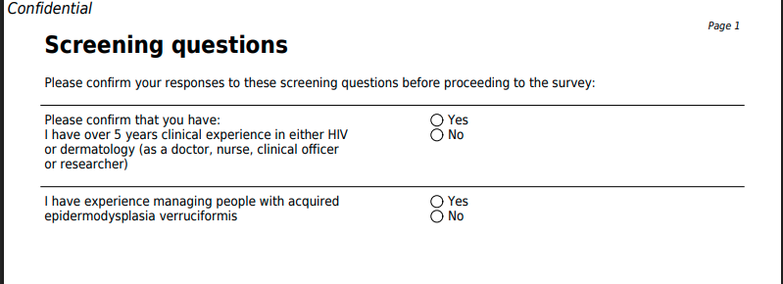

APPENDIX 3: Participant Information Sheet Version 1.0, Date: 13.2.26

Participant Information Sheet

Title of Project: HIVE MIND - Establishing globally relevant diagnostic criteria for HIV associated acquired epidermodysplasia verruciformis: an international Delphi study.

Introduction
We would like to invite you to take part in a research study. Joining the study is entirely up to you. Before you decide, you need to understand why the research is being done and what it would involve. Please read this information sheet clearly and feel free to email the study team with any questions or clarifications on Sophie.kelly@lshtm.ac.uk. Ask questions if anything you read is not clear or you would like more information. Please feel free to talk to others about the study if you wish. Take time to decide whether or not to take part.

What is the purpose of the study?
The London School of Hygiene and Tropical Medicine (LSHTM) are conducting research to understand how to best diagnose acquired epidermodysplasia verruciformis in people living with HIV. The aim of this study is to gather expert opinions and to reach agreement on the best approach to screening and diagnosis of acquired epidermodysplasia verruciformis.

We hope that by the end of the study we will produce screening and diagnostic criteria for HIV-associated acquired epidermodysplasia verruciformis that can be applied in both high and low resource settings. This will allow better diagnosis, epidemiological mapping and long-term research of this condition.

Why have I been asked to take part?
You have been invited because you are an expert in HIV medicine or dermatology.

Do I have to take part?
No. It is up to you to decide to take part or now. If you don’t want to take part, that’s ok and there will be no negative consequences. If you agree to take part, we will then ask you to electronically sign a consent form.

What will happen to me if I take part?
If you agree to take part, you will be asked to complete at least three rounds of online surveys over a period of four to twelve months. We would expect each survey to take no more than 20 minutes.

What will I have to do?

Joining survey: Before proceeding to the first survey you will be asked to confirm that you have ≥5 years’ experience as a doctor, nurse, clinical officer or researcher in the field of HIV or dermatology AND that you have experience looking after people with acquired epidermodysplasia verruciformis.

In the first survey you will be asked to provide some details about your demographics (age, gender), your job role and experience managing people with acquired EV. This is to ensure that we recruit a diverse panel of experts from around the world with appropriate experience in the area.

You will also be asked to provide the email address that you would like the study team to contact you on and given the option to provide a phone number for the study team to contact you on. These details will be stored securely in a password protected file on a secure server. You may ask us to remove your contact details at any time.

We will review the results of the screening survey and, provided we have a total of 20 participants, recruitment will be closed at 2 weeks. If your background doesn't meet the specific requirements for this study, we will notify you and your contact details will be deleted.

Round 1: In the first round of the study, you will be asked a series of questions about the way that you diagnose acquired epidermodysplasia verruciformis in your practice and to list all features that you think could be included in a diagnostic criteria for this condition. These responses of all participants will be reviewed and collated by the study team.
Round 2: In round two you will be asked to review the collated feedback from round 1. You will be presented with a list of features that could be included in diagnostic criteria for acquired epidermodysplasia verruciformis and will be asked to rate each feature on a scale from “not at all important” to “essential”. You may be asked a series of open and closed questions about the importance of various features in the diagnosis of acquired epidermodysplasia verruciformis.

Round 3: in round 3 you will be asked to review the feedback from round 2 and a set of draft screening and diagnostic criteria. You will be asked to rate your agreement with each feature of the screening and diagnostic criteria and your support with adoption of the overall criteria. You will be asked to give any comments on anything that you think should be changed.
The rounds will continue until >80% of participants agree with that the screening and diagnostic criteria should be adopted. If after 5 rounds there is still no agreement on the criteria you may be invited to an online meeting to discuss changes to be made in subsequent rounds.

At the end of the Delphi rounds you will be asked whether you want us to keep you updated with any progress on publication of results and whether you would like your contribution to be acknowledged by name in any publications. This is entirely voluntary and not required for study participation.

What are the possible risks and disadvantages?
The possible disadvantage of this study is the time burden. We would ask you to fill out a twenty-minute survey approximately once a month until study completion. We will collect some data about you – your age group, sex, gender, ethnicity and country of practice. We will also collect your survey responses. Your survey responses and demographic data will be kept securely under a participant ID. Your name and contact information will be kept in a separate password protected file and only accessible to the study team. Your survey responses will be collated and anonymised before sharing with the other participants in the expert panel.

What are the possible benefits?
The information we get from the study will help to produce diagnostic criteria that can be applied globally to aid the diagnosis of acquired epidermodysplasia verruciformis.

What if something goes wrong?
If you have a concern about any aspect of this study, you should ask to speak to the researchers who will do their best to answer your questions (Sophie.kelly@lshtm.ac.uk) . If you remain unhappy and wish to complain formally, you can do this by contacting The Research Governance and Integrity Office (RGIO) at rgio@lshtm.ac.uk.

Can I change my mind about taking part?
Yes. You can withdraw from the study at any time. You just need to email the study team (Sophie.kelly@lshtm.ac.uk) to tell them that you don’t want to be in the study anymore and you will not receive any further emails or reminders. If you withdraw from the study within 72 hours of submitting your survey, we can remove your survey responses from the collated feedback and further analysis. If you ask to withdraw after 72 hours, we cannot guarantee that we will be able to remove your responses from the feedback or analysis.

How will we use information about you?
We will need to use information from you for this research project. This information will include your name and contact details so that we can send you the online questionnaires and any reminders. Your name and contact details will be kept in a password protected file, separate from your survey responses. People who do not need to know who you are will not be able to see your name or contact details. Your survey data will have a code number instead.

International transfers
Your data will not be shared outside the UK.

How will we use information about you after the study ends?
Once we have finished the study, we will keep some of the data so we can check the results. We will write our reports in a way that no-one can work out that you took part in the study. We will keep your study data for ten years after study completion. The study data will then be fully anonymised and securely archived or destroyed.

What are your choices about how your information is used?
- You can stop being part of the study at any time, without giving a reason, but we will keep information about you that we already have
- You have the right to ask us to remove, change or delete data we hold about you for the purposes of the study. We might not always be able to do this. If so, we will tell you why we cannot do this

Where can you find out more about how your information is used?
You can find out more about how we use your information
- by asking one of the research team
- by sending an email to DPO@lshtm.ac.uk

What will happen to the results of this study?
The study results will be published in a medical journal so that other clinicians can learn from them. Your personal information will not be included in the study report and there is no way that you can be identified from it without your explicit consent. Given the important contribution to the medical and scientific community you are making as part of a Delphi panel, we will give all participants the opportunity to be recognised by name in the acknowledgements of the study report. This is entirely voluntary and not required for study completion.

The results will be written up as part of SKs PhD thesis and will be directly used to inform further studies to better understand the epidemiology and impact of acquired epidermodysplasia verruciformis in people with HIV.

Who is organising and funding this study?
This study is organised by the London School of Hygiene and Tropical Medicine and is funded by Wellcome as part of the CREATE PhD programme.

Who has reviewed this study?
All research involving human participants is looked at by an independent group of people, called a Research Ethics Committee, to protect your interests. This study has been reviewed and given favourable opinion by The London School of Hygiene and Tropical Medicine Research Ethics Committee (LSHTM Ethics Ref: 33189)

Further information and contact details
Thank you for taking time to read this information sheet. If you think you will take part in the study please read and sign the consent form on the following page.
If you would like any further information, please contact the study PI (Sophie.kelly@lshtm.ac.uk) who can answer any questions you may have about the study.

APPENDIX 4: Consent Form

Title of Project: HIVE MIND - Establishing globally relevant diagnostic criteria for HIV associated acquired epidermodysplasia verruciformis: an international Delphi study.

Version number: 1.0
Date: 13.2.26

Name of PI/Researcher responsible for project: Sophie Kelly Sophie.kelly@lshtm.ac.uk
Statement | Yes
I confirm that I have read and understood the information sheet dated Feb 2026 (version 1.0) for the above-named study. I have had the opportunity to consider the information, ask questions and have these answered satisfactorily.
I understand that my consent is voluntary and that I am free to withdraw this consent at any time without giving any reason and without my legal rights being affected.
I give permission for my survey responses to be used during the Delphi process and to be accessed by the research team. I understand that my name will not be linked to the research materials and I will not be identifiable during the Delphi survey or the subsequent reports.
I understand that I can request the removal of my data at any time. However, if more than 72 hours have passed since my survey submission, it may not be possible to remove my individual responses from the collated feedback and analysis.
I understand that I will be given the option to be recognised in any final manuscripts acknowledgements and that this is entirely voluntary and not required to take part in the study.
I understand that data about me may be shared via a public data repository or by sharing directly with other researchers, and that I will not be identifiable from this information
I agree to taking part in the above-named study.
Please electronically sign in the box:
Name
Date
Participant declaration: I acknowledge that by opting in to the HIVE MIND study that I agree to all the statements above. I understand that opting in to this study is the equivalent of signing a physical document.

Please enter your email address for ongoing communication: ______________

Please enter your phone number if you are happy for the study team to contact you by SMS or WhatsApp for reminders ______________________

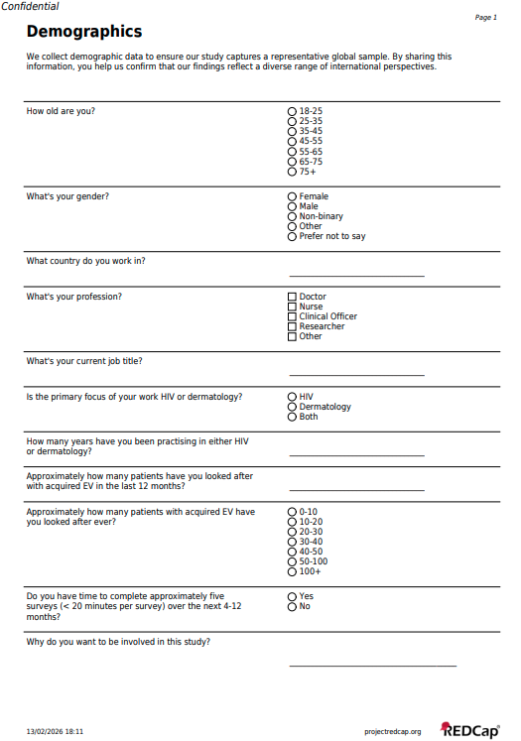
APPENDIX 5: Survey 1 – Demographics and Experience

APPENDIX 6: Screen on completion of Survey 1. Note this is also sent via email.
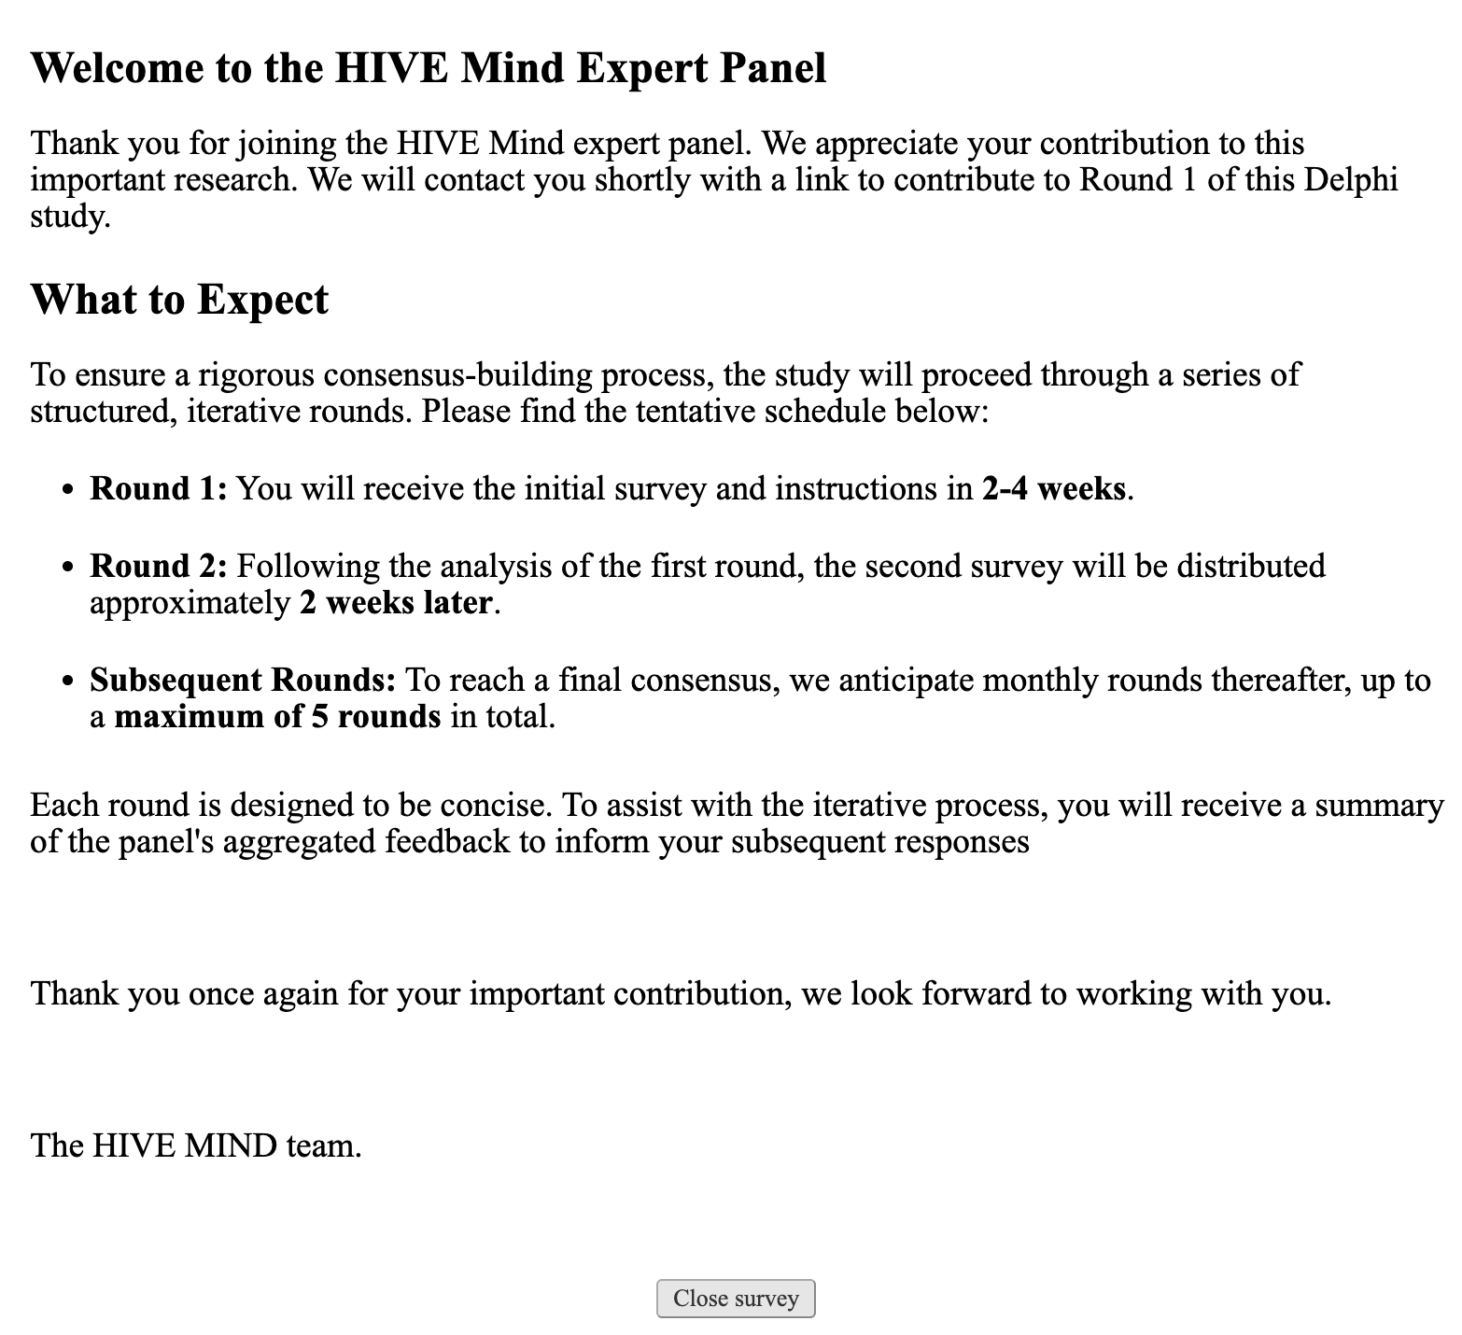

APPENDIX 7: Round 1 REDCap Survey instruments.
(Note participants will have to re-affirm their consent before proceeding to the instruments below)
