**Overview of Survey Advertisement Strategies and Visual Campaigns Across Six Cities**

**Table 1:** Advertising Platforms, Networks, and Formats

|  |  |  |
| --- | --- | --- |
| Advertising Platforms | Advertising Networks | Advertisement Formats |
| Google | YouTube Gmail Google Search Google Display Google Discover | Text, Images, Video |
| Meta | FaceBook Instagram | Image, Video, Stories, Carousel, Reels |

|  |  |  |  |
| --- | --- | --- | --- |
|  |  |  |  |

**Figure 1:** Examples of images used in the advertisement campaign targeting participants in Port Harcourt, Nigeria.

|  |  |  |
| --- | --- | --- |
|  |  |  |

**Figure 2:** Examples of images used in the advertisement campaign targeting participants in Manilla, Philippines.

|  |  |  |  |
| --- | --- | --- | --- |
|  |  |  |  |

**Figure 3:** Examples of images used in the advertisement campaign targeting participants in Dar es Salaam, Tanzania.

|  |  |  |  |
| --- | --- | --- | --- |
|  |  |  |  |

**Figure 4:** Examples of images used in the advertisement campaign targeting participants in Accra, Ghana.

|  |  |  |  |
| --- | --- | --- | --- |
|  |  |  |  |

**Figure 5:** Examples of images used in the advertisement campaign targeting participants in Kumasi, Ghana.

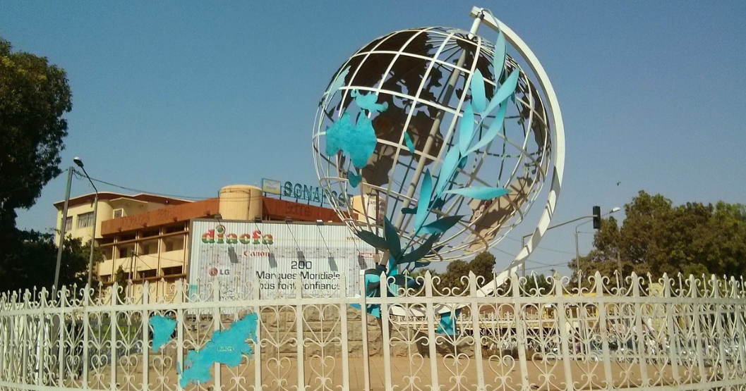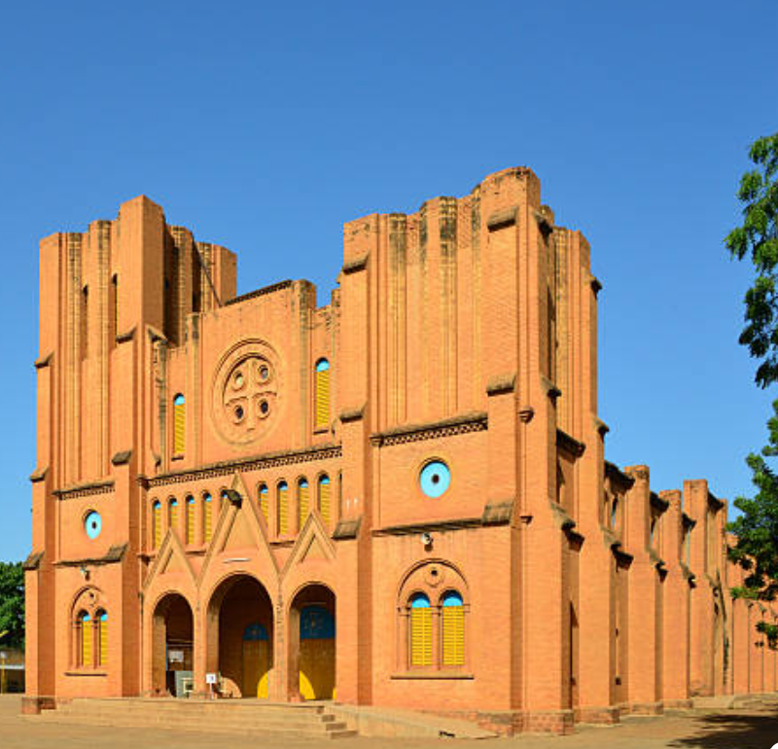

**Figure 6:** Examples of images used in the advertisement campaign targeting participants in Ouagadougou, Burkina Faso.

**Table 2:** Cities and Languages Used in Advertisement Campaigns

|  |  |
| --- | --- |
| **City** | **Language of Advertisement** |
| Port Harcourt | English |
| Manilla | English |
| Dar es Salaam | Swahilli |
| Accra | English |
| Kumasi | English |
| Ougadougou | French |

.