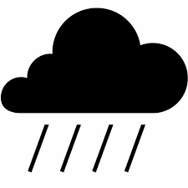

**DRY SEASON**

**TILI KANDO**

**CHEDU**

**RAINY SEASON**

**SUMMA KON**

**NDUGU**

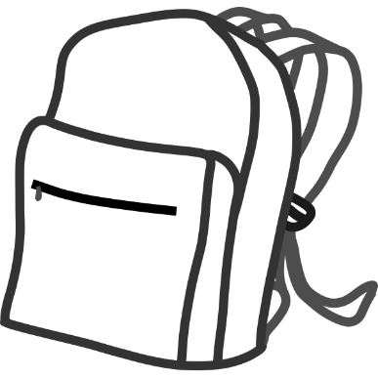

**ADULT MAN**

**KEY KEBA**

**MAWADO GORKO**

**SMALL CHILDREN**

**DINDINYOW**

**SUKABE TOKASBE**

**SCHOOL-AGED CHILDREN**

**KARAMONTO DINDINYOW**

**SUKABA JARGOBA**

**ADULT WOMAN**

**MUSO KEBA**

**MAWADO DABO**