

**STOP/REDUCE HANDWASHING**

**LOO/ BULO-KUOR ATALA**

**ACHUE/AUSUTU LOTEGUL JUDA**

**WASHING FACE**



**LIMIT DRINKING**

**MINWOO ATALA**

**AUSATA YARUGOL**

**WASHING FACE**



**STOP/LIMIT BATHING**

**LOO/ BALA-KUOR ATALA**

**ACHUED/AUSUTAA LOTAGUL**

**WASHING FACE**



**LIMIT COOKING**

**TABIRO ATALA**

**AUSUTA NDAFUGUL**

**WASHING FACE**



**COOK DIFFERENT FOODS** *(THAT USE LESS WATER)*

**TABIRO AKE BULO FALINENG NEE BANG**

**SANSU DIFUGOL**

**WASHING FACE**

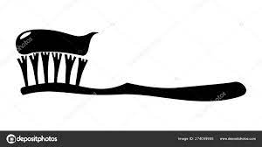

**STOP/ REDUCE BRUSHING TEETH**

**LOO/ DA-KUOR ATALA**

**ACHUE/AUSUTU LOTEGUL HANKOW**



**STOP/REDUCE LAUNDRY**

**LOO/KURO ATALA**

**ACHUE/AUSUTU LOTEGUL KEJI**

**WASHING FACE**

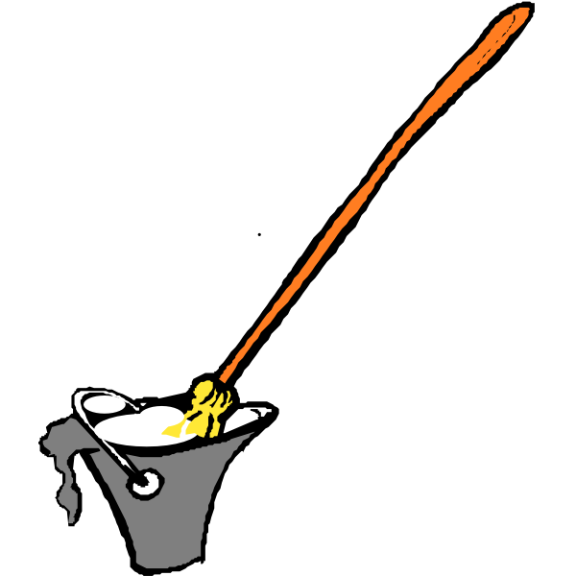

**STOP/REDUCE CLEANING HOUSE**

**LOO/ BUNG FITO ATALA**

**ACHUE/AUSUTU FITIGOL SULDU**





**WASH HANDS IN A SHARED CONTAINER**

**MO BEY EBULOKU KERAWKONO**

**LOTAGELO JUDA DULARA WAA TARRA**

 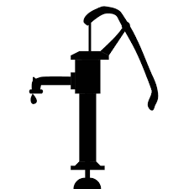

**FIND ALTERNATIVE WATER SOURCES**

**FOO GESOTO SULA DOO LI BALIBULU BANG**

**NDOJOKE PAJA KUDA NO KABAR NDO DIYAM**



**LIMIT WATERING GARDEN**

**GARDEN GIBOWON ATALA**

**AUSUTA ROSUGUL GARDEN**

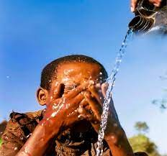

**STOP/REDUCE WASHING FACE**

**LOO / NIAH-KUOR ATALA**

**ACHUCE/AUSUTA LOTUGULO YASO**



**STOP/ REDUCE WASHING BASINS/UTENSILS**

**LOO/ BULI-KUOR ATALA**

**ACHUE/AUSTO LOTEGULO KAKI**



**REDUCE WATER FOR DOMESTIC ANIMALS**

**GIO ATALA BEGANUL**

**AUSUTA NDIAMA DAMI NDE**

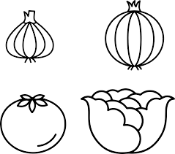

**STOP/REDUCE WASHING VEGETABLES/FOOD**

**LOO/ KELADAJORONG KUOR ATALA**

**ACHUE/ASUTA LOTEGUL KONDAFATAGO**

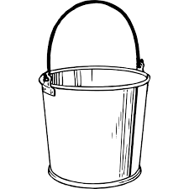

**STORE WATER FOR LONGER**

**KE GIO LONDI FOH AYE ME**

**MOTUGOL DIEM HA BOYA**

**STORE WATER FOR LONGER**



**BORROW WATER FROM NEIGHBOURS**

**GIO FUU SINYOLU BULU**

**NYAMLAGOL NDIAMA HA KUDIMAMON MA**



**BUY WATER/ PAY SOMEONE TO FETCH WATER**

**GIO SANGOW/ KAMOJO KATA GIO SANGNA**

**CHODAA NDIAMA/ YO UGOL GODO JUGANA NDIAMA**

