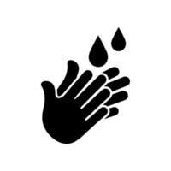

**DRINKING**

**MINWOO**

**YARGO**

**WASHING FACE**

**HANDWASHING BULO-KUOR**

**LOTEGUL JUREH**

**WASHING FACE**



**COOKING**

**TABOROR**

**DEFOGUL**

**WASHING FACE**

**BATHING**

**BALA-KUOR**

**LOTAGUL**

**WASHING FACE**

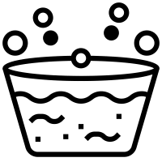

**LAUNDRY**

**KURO**

**LOTEGUL KEJI**

**WASHING FACE**

**TOILET**

**KAMO**

**KAMA**

**WASHING FACE**

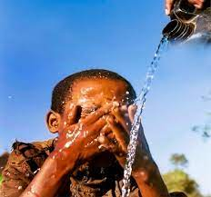



**WASHING FACE**

**NIAH-KUOR**

**LOTEGUL YASSO**

**BRUSHING TEETH**

**DA-KUOR**

**LOTEGUL HANKOW**

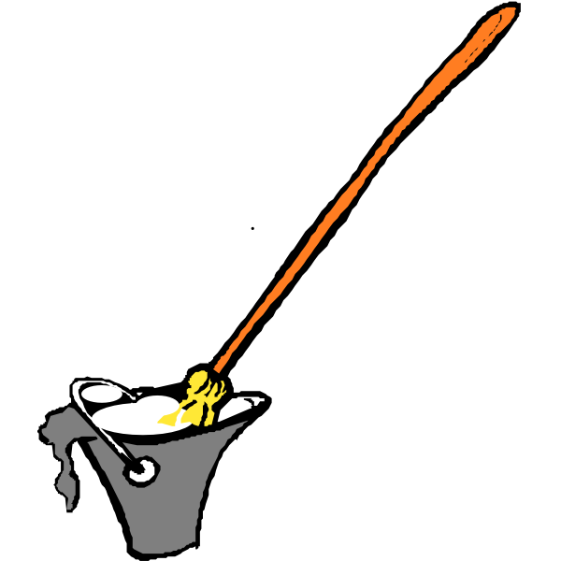

**WATERING GARDEN**

**GARDEN GIBOWON**

**ROSEGUL GARDEN**

**CLEANING HOUSE**

**BUNG FITO**

**FITIGOL SULDU**

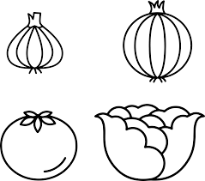****

**ABLUTION**

**SALI GI MOTO**

**NANGUGOL SALIGEH**

**WASHING VEGETABLES/FOOD**

**KELADAJORONG KUOR**

**LOTEGUL CONTEFATAGO**





**WATER FOR DOMESTIC ANIMALS**

**GIO PROU BEGANUL**

**DIEM PRO DAMDEDI**

**WASHING BASINS/UTENSILS**

**BULI-KUOR**

**LOTEGUL KAKI**