Supporting information accompanying paper Belachew et al. Effect of implementing digital adherence technologies on the use of health care providers time and the human resource cost of tuberculosis treatment adherence support in Ethiopia.

Survey Form A – 10 observations (one per patient) per health facility. The form was completed for consecutive patients as they left the consultation with healthcare workers.

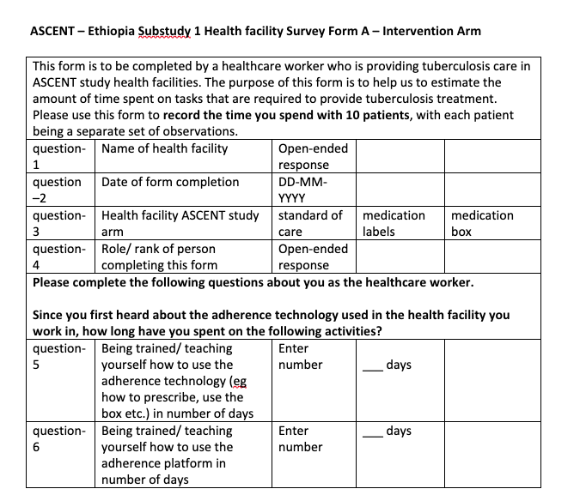
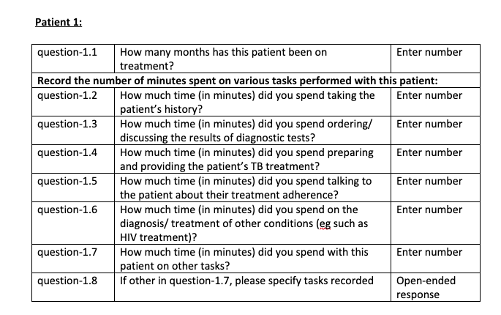
Health Facility Survey Form B - 6 observations (one per week) per health facility in each of the three study arms.

