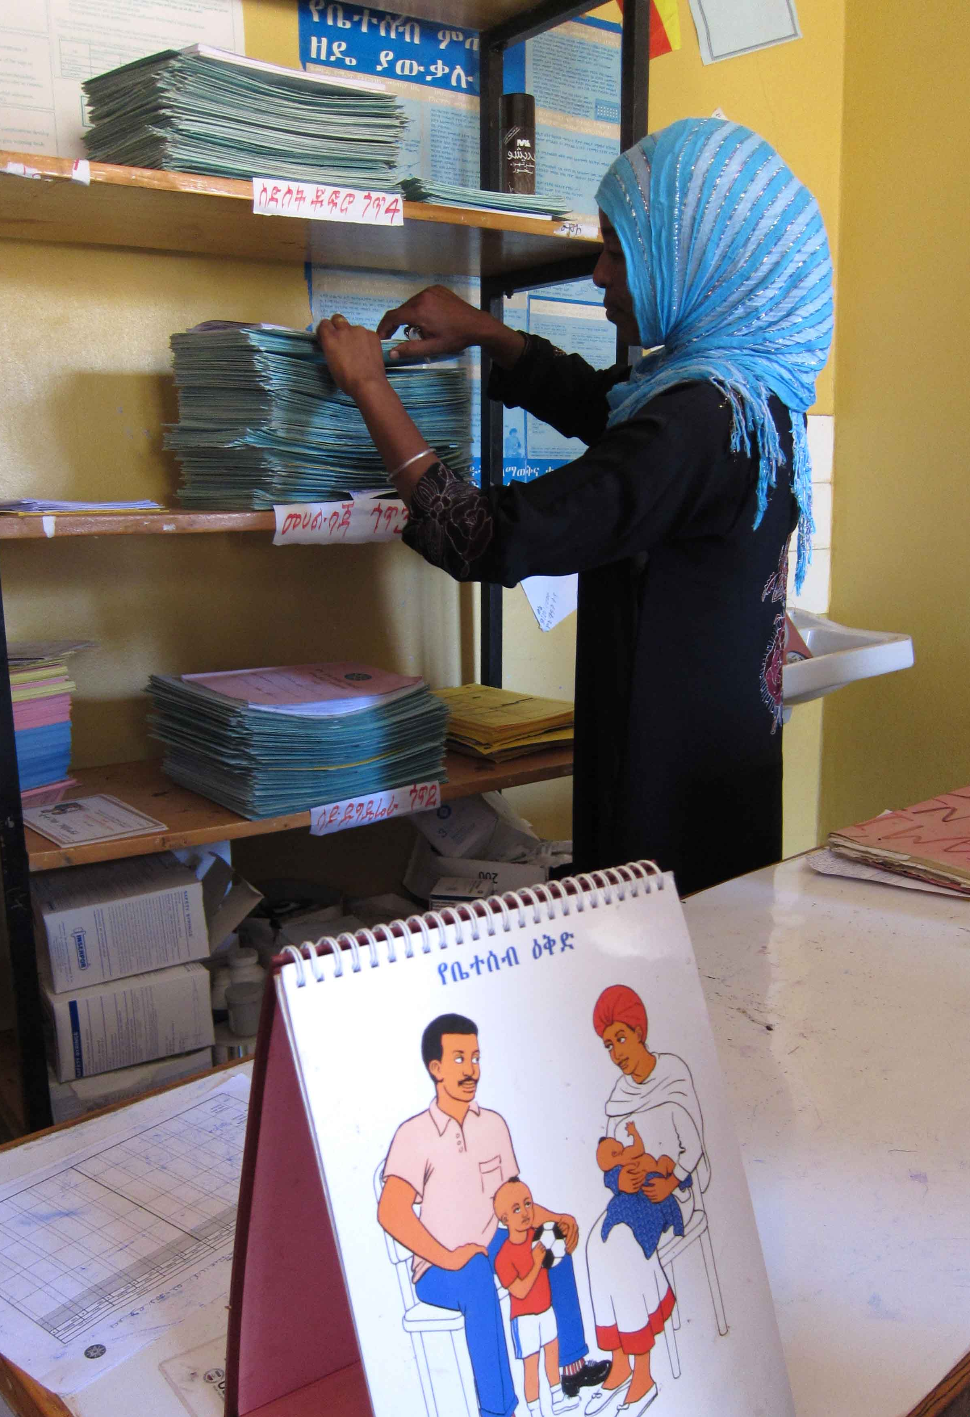
Data-Informed Platform for Health (DIPH)

Plans based on local data
In low-resource settings, the use of local health data for planning is usually limited. Information sharing across governmental and other service providers will reduce duplication of effort and ensure resources are not wasted. In India and Ethiopia, multiple data sources exist at district or woreda level. The Health Management Information System reflects health facility utilisation and performance; local programme staff report on human and physical resources; and non-governmental organisations report on community-based activities. This information could be shared by programme managers, working together, with technical support to act as a catalyst. The shared data could empower local decision making, repositioning health service delivery in congruence with the available resources and community maternal and newborn health needs. Currently it is difficult to ascertain the causes of any change in MNH outcomes.
Health Extension Worker, Ethiopia.
© Dr Neil Spicer

Data-informed platform for health
We propose the “Data-Informed Platform for Health” (DIPH), a framework to guide coordination, bringing together key data from public and private health sectors on inputs and processes that could influence maternal and newborn health. The dual primary aims are:
- to promote the use of local data for decision-making and priority-setting at local health administration level;
- to promote the use of local data on inputs and processes for programme appraisal and comparison at the regional or zonal level

Figure 1: Data-Informed Platform for Health Framework
The DIPH concept has its roots in the “District Evaluation Platform” approach (Victora, Lancet 2010). The framework should be embedded, owned and sustained by local health departments. The DIPH operates at local area and regional level, and includes both the “data-informed area for health” and the “data-informed region for health”. Networks for coordination and feedback are shown in Figure 1. Area health administration will periodically assess the available resources and activities (inputs and processes) by all key health providers and will share this information for mutual decision making on health service provision and research.
Data-Informed
Platform for Health
Data-Informed
Area for Health
(inputs & processes)

Level 1 primary goal
Health decision-making based on local data

Data-Informed
Area for Health
(inputs & processes)

Data-Informed
Area for Health
(inputs & processes)

Level 2 primary goal
Appraisal & comparison of initiatives based on local data
Level 2
Secondary administrative unit of the health system

Level 1
Primary administrative unit of the health system

A local health area is considered as the operating unit for the DIPH, assuming that this is the lowest effective level of decision making in a health system – in Ethiopia, this would be the woreda; in Nigeria, the Local Government Area; and in India, it would be the district.

Features of the DIPH

Benefits for local area health service providers: an example
A local government health team is concerned about ongoing poor newborn survival figures, despite carrying out a number of training activities to improve newborn care in 2010 and 2011. In addition, they feel they have neglected maternal care over the same time period. However, when they share their data with non-governmental health teams, they find that maternal care in the area has benefited from major investments, rather greater than newborn care. This holistic picture empowers the health planners to plan for their local needs effectively and bring all the key service providers together for priority setting and resource reallocation. They decide to continue to invest government funds in newborn care and to continue to share information on a regular basis.

At the local area level, the approach provides a mechanism to bring governmental and non-governmental service providers to a common forum on a regular basis, to share data in a systematic manner, and to use the resulting information as a tool in priority setting for resource allocation and needs assessment for further acquisition of funds.
At regional, zonal or national level, the DIPH provides information for the appraisal of effectiveness of programs or initiatives across local areas and regions. Data from local areas will reflect inputs and processes for initiatives and programmes affecting maternal and newborn health, whether these are new or old. These can be synthesised to create a measure of programme implementation strength for each local area, which in turn can be used in the evaluation of the effects of large-scale programmes on health outcomes.

Data sources: links to the Health Management Information System
The DIPH is complementary to the Health Management Information system, differing as follows:
- The DIPH focus is on inputs and processes in health service provision - as compared to service uptake and health outcome recorded through routine HMIS
- The DIPH will bring together the key data from both governmental and non-governmental service providers. The focus is on effective use of existing data sources for local level planning and decision making.
- The DIPH will focus on sharing of a few key indicators rather than a comprehensive range of data.
The DIPH will use some HMIS data, but also include data on commodities, training, monitoring, and supervision, from government and non-governmental sources. A limited amount of primary data collection may be carried out.

Next steps
The DIPH is an innovative approach: similar approaches are being developed in a few low income countries. The IDEAS project team (ideas.lshtm.ac.uk) are interested to explore interest and potential of the DIPH to assess the scale up of maternal and newborn health initiatives in India, Ethiopia and Nigeria. A feasibility phase is ongoing, and will be followed by pilot work.

Victora CG, Black RE, Boerma JT, Bryce J. .Measuring impact in the Millennium Development Goal era and beyond: a new approach to large-scale effectiveness evaluations. Lancet. 2011 Jan 1;377(9759):85-95.
John Spencer , Charles Pill , Siân Curtis a Edward Kunyanga. A new approach to large-scale effectiveness evaluation. The Lancet, Volume 377, Issue 9774, Page 1317, 16 April 2011.

