Extended Data

The effect of cumulative early life adversities, and their differential mediation through hair cortisol levels, on childhood growth and cognition: Three-year follow-up of a birth cohort in rural India

Debarati Mukherjee, PhD¹*, Sunil Bhopal, PhD^{2,3}*, Supriya Bhavnani, PhD⁴, Kamal Kant Sharma, MSc⁴, Reetabrata Roy^{3,4}, Gauri Divan, MRPCH⁴, Siddhartha Mandal, PhD⁵, Seyi Soremekun, PhD^{3,6,7}, Betty Kirkwood, FMedSci³, Vikram Patel, FMedSci^{4,8,9#}.

* Joint first authors
# Corresponding author: Prof. Vikram Patel; Email: vikram_patel@hms.harvard.edu

(Extended Data) Fig. 1. Summary of games on Developmental Assessment on an E-Platform (DEEP) to test cognition in preschool children
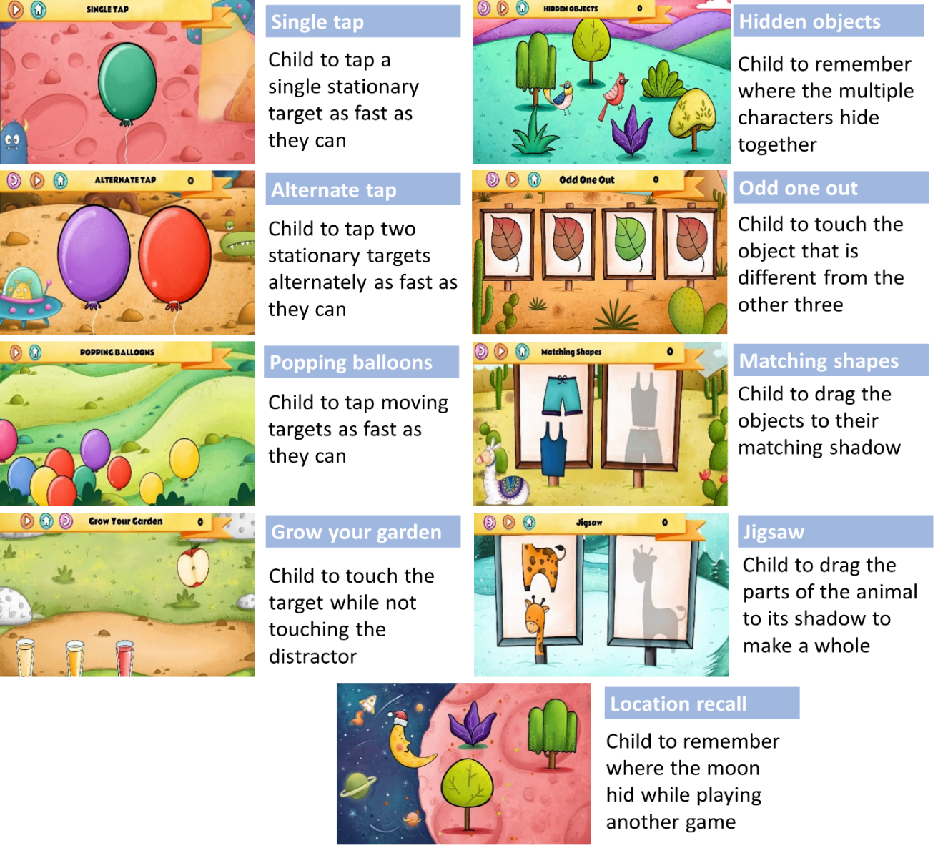
DEEP comprises 9 games to test various components of cognition such as processing speed, manual coordination, response inhibition, divided attention, reasoning, visual form perception, visual integration and working memory. This figure lists the game names, example screenshots and main instructions for gameplay on DEEP.

(Extended Data) Table 1: Association between cumulative adversity (total score and quintiles) measured at 12 months and growth and cognition (DEEP) measured at 3-years (N = 1124)
*represents that some participant data was imputed (see Supplementary Table 1 for details).
Total Adversity Score | n* | DEEP z-score |  | Anthropometry z-score
 |  | Mean score | 95% CI | Weight-for-age | 95% CI | Height-for-age | 95% CI
0 | 102 | 0.30 | (0.09, 0.52) | -0.95 | (-1.13, -0.77) | -1.15 | (-1.34, -0.97)
1 | 180 | 0.21 | (0.03, 0.38) | -1.17 | (-1.31, -1.03) | -1.29 | (-1.44, -1.15)
2 | 194 | 0.07 | (-0.11, 0.24) | -1.33 | (-1.46, -1.19) | -1.49 | (-1.63, -1.34)
3 | 178 | 0.13 | (-0.05, 0.31) | -1.33 | (-1.48, -1.19) | -1.48 | (-1.64, -1.33)
4 | 154 | -0.07 | (-0.25, 0.12) | -1.49 | (-1.64, -1.33) | -1.65 | (-1.82, -1.49)
5 | 108 | -0.17 | (-0.38, 0.05) | -1.64 | (-1.82, -1.46) | -1.88 | (-2.08, -1.68)
6 | 83 | -0.32 | (-0.57, -0.08) | -1.69 | (-1.89, -1.49) | -1.96 | (-2.17, -1.74)
7 | 44 | -0.27 | (-0.60, 0.07) | -1.72 | (-2.00, -1.44) | -1.91 | (-2.21, -1.61)
8+ | 80 | -0.43 | (-0.66, -0.20) | -2.00 | (-2.20, -1.80) | -2.16 | (-2.38, -1.95)
Decrease per adversity |  | -0.08 | (-0.11, -0.06) | -0.11 | (-0.13, -0.09) | -0.12 | (-0.14, -0.09)
p-trend |  | <0.001 |  | <0.001 |  | <0.001
Adversity factors PCA (quintiles) | 1 | 0.20 | (0.03, 0.37) | -1.07 | (-1.19, -0.95) | -1.25 | (-1.38, -1.12)
 | 2 | 0.21 | (0.04, 0.37) | -1.25 | (-1.37, -1.13) | -1.36 | (-1.49, -1.23)
 | 3 | 0.05 | (-0.11, 0.20) | -1.39 | (-1.51, -1.27) | -1.57 | (-1.70, -1.44)
 | 4 | -0.08 | (-0.24, 0.08) | -1.52 | (-1.64, -1.40) | -1.70 | (-1.83, -1.57)
 | 5 | -0.36 | (-0.52, -0.20) | -1.83 | (-1.95, -1.71) | -2.05 | (-2.18, -1.92)
Decrease per quintile (linear) |  | -0.14 | (-0.18, -0.10) | -0.2 | (-0.2, -0.1) | -0.2 | (-0.2, -0.2)
p-trend |  | <0.001 |  | <0.001 |  | <0.001

(Extended Data) Table 2: Association between domain specific adversity scores and child outcomes (N = 1124)
Association estimates were computed from mixed-effects linear regression models adjusted for gender and age at 36-month assessment, with cluster as the random effect and intervention allocation arm as the fixed effect.

Adversity type | No. factors |  | Range |  | DEEP | 36m WAZ | 36m HAZ
SES |  | 6 | 0-6 | Mean with 0 factors  (95% CI) | -0.01  (-0.25, 0.23) | -1.20  (-1.29, -1.11) | -1.32  (-1.42, -1.21)
 |  |  |  | Change with increasing factors (95% CI) | -0.19  (-0.24, -0.14) | -0.17  (-0.22, -0.13) | -0.21  (-0.26, -0.17)
 |  |  |  | p for slope | <0.001 | <0.001 | <0.001
Maternal stress |  | 6 | 0-4 | Mean with 0 factors  (95% CI) | -0.09  (-0.35, 0.16) | -1.28  (-1.38, -1.18) | -1.47  (-1.59, -1.35)
 |  |  |  | Change with increasing factors (95% CI) | -0.09  (-0.16, -0.03) | -0.14  (-0.21, -0.08) | -0.09  (-0.16, -0.02)
 |  |  |  | p for slope | 0.007 | <0.001 | 0.008
Relationship |  | 4 | 0-3 | Mean with 0 factors  (95% CI) | 0.06  (-0.20, 0.32) | -1.13  (-1.24, -1.03) | -1.32  (-1.45, -1.20)
 |  |  |  | Change with increasing factors (95% CI) | -0.18  (-0.25, -0.10) | -0.25  (-0.32, -0.18) | -0.22  (-0.29, -0.15)
 |  |  |  | p for slope | <0.001 | <0.001 | <0.001
Child |  | 6 | 0-5 | Mean with 0 factors  (95% CI) | -0.13  (-0.39, 0.12) | -1.29  (-1.40, -1.18) | -1.42  (-1.55, -1.29)
 |  |  |  | Change with increasing factors (95% CI) | -0.01  (-0.07, 0.05) | -0.10  (-0.15, -0.04) | -0.14  (-0.19, -0.08)
 |  |  |  | p for slope | 0.767 | <0.001 | <0.001

(Extended Data) Table 3: Association between chronic stress as measured by log hair cortisol levels at 12 months and growth and cognition measured at 3-years (N = 607)
Association estimates were computed from mixed-effects linear regression models adjusted for gender and age at 36-month assessment, with cluster as the random effect and intervention allocation arm as the fixed effect.
Log hair cortisol | DEEP-z-score | WAZ | HAZ
β-coef (95% CI) | -0.09 (-0.16, -0.01) | -0.078 (-0.15, - 0.004) | -0.12 (-0.20, - 0.04)
p-value | 0.04 | 0.142 | 0.005

