Back
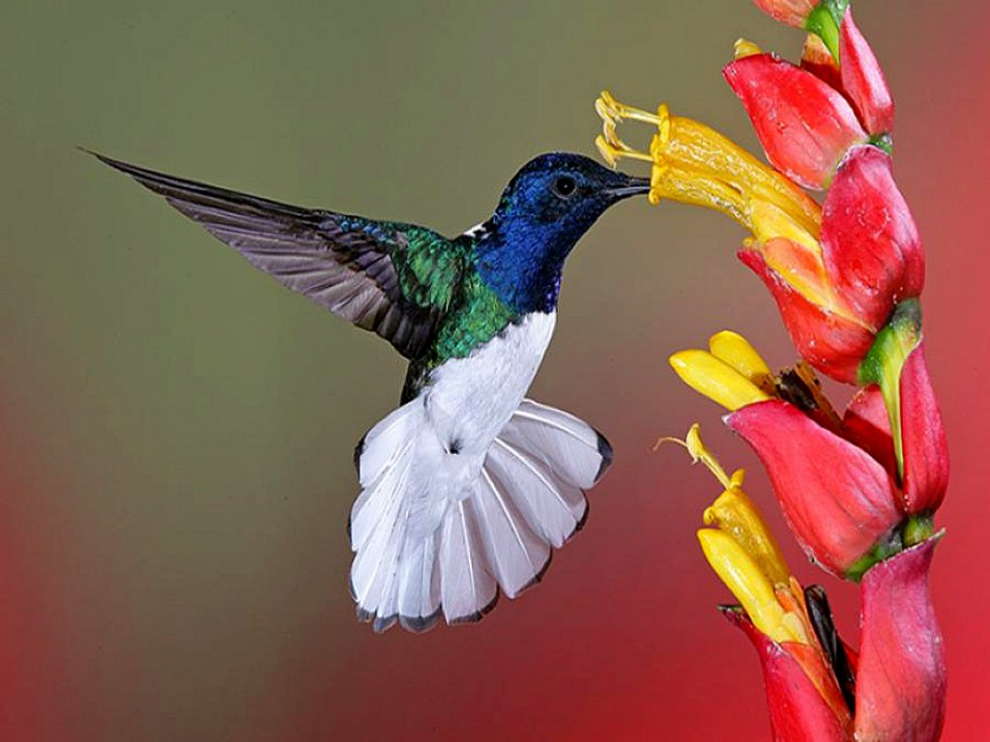
Participant ID: __l__l__l__l__l__l__l
Date: l__l__l/l__l__l/l__l__l__l__l
School:
Estimated date of menarche onset: l__l__l/l__l__l/l__l__l__l__l
Week 1 |  | School | Period
Day | Date | Yes Half day No Holiday Travelled | No Light period Moderate period Heavy period
Sunday | 29 Jan 17
Monday | 30 Jan 17
Tuesday
Wednesday
Thursday
Friday
Saturday

Week 2 |  | School | Period
Day | Date | Yes Half day No Holiday Travelled | No Light period Moderate period Heavy period
Sunday
Monday
Tuesday
Wednesday
Thursday
Friday
Saturday

Week 3 |  | School | Period
Day | Date | Yes Half day No Holiday Travelled | No Light period Moderate period Heavy period
Sunday
Monday
Tuesday
Wednesday
Thursday
Friday
Saturday

Week 4 |  | School | Period
Day | Date | Yes Half day No Holiday Travelled | No Light period Moderate period Heavy period
Sunday
Monday
Tuesday
Wednesday
Thursday
Friday
Saturday

Week 5 |  | School | Period
Day | Date | Yes Half day No Holiday Travelled | No Light period Moderate period Heavy period
Sunday
Monday
Tuesday
Wednesday
Thursday
Friday
Saturday

Week 6 |  | School | Period
Day | Date | Yes Half day No Holiday Travelled | No Light period Moderate period Heavy period
Sunday
Monday
Tuesday
Wednesday
Thursday
Friday
Saturday

Week 7 |  | School | Period
Day | Date | Yes Half day No Holiday Travelled | No Light period Moderate period Heavy period
Sunday
Monday
Tuesday
Wednesday
Thursday
Friday
Saturday

Week 8 |  | School | Period
Day | Date | Yes Half day No Holiday Travelled | No Light period Moderate period Heavy period
Sunday
Monday
Tuesday
Wednesday
Thursday
Friday
Saturday

February 2017 March 2017
Sunday | Monday | Tuesday | Wednesday  1 | Thursday  2 | Friday  3 | Saturday  4
5 | 6 | 7 | 8 | 9 | 10 | 11
12 | 13 | 14 | 15 | 16 | 17 | 18
19 | 20 | 21 | 22 | 23 | 24 | 25
26 | 27 | 28
Sunday | Monday | Tuesday | Wednesday  1 | Thursday  2 | Friday  3 | Saturday  4
5 | 6 | 7 | 8 | 9 | 10 | 11
12 | 13 | 14 | 15 | 16 | 17 | 18
19 | 20 | 21 | 22 | 23 | 24 | 25
26 | 27 | 28 | 29 | 30 | 31

April 2017 May 2017
Sunday | Monday | Tuesday | Wednesday | Thursday | Friday | Saturday  1
2 | 3 | 4 | 5 | 6 | 7 | 8
9 | 10 | 11 | 12 | 13 | 14 | 15
16 | 17 | 18 | 19 | 20 | 21 | 22
23 | 24 | 25 | 26 | 27 | 28 | 29
30
Sunday | Monday  1 | Tuesday  2 | Wednesday  3 | Thursday  4 | Friday  5 | Saturday  6
7 | 8 | 9 | 10 | 11 | 12 | 13
14 | 15 | 16 | 17 | 18 | 19 | 20
21 | 22 | 23 | 24 | 25 | 26 | 27
28 | 29 | 30 | 31

